***Dt : 23/8/2022***

***\*imp***

***Operators in Java:***

***=>Operator is a Special symbol which is used to perform some***

***operation.***

***=>Operators in Java are categorized into the following:***

***1.Arithmetic Operators***

***2.Relational Operators***

***3.Logical Operators***

***4.Increment-Decrement Operators***

***1.Arithmetic Operators:***

***=>Arithmetic Operators are used to perform basic operations***

***or fundamental Operations.***

***Operator Meaning***

***+ Addition***

***- Subtraction***

***\* Multiplication***

***/ Division***

***% ModDivision***

***2.Relational Operators:***

***=>Relational operators are used to compare two values and***

***generate boolean result.***

***Operator Meaning***

***> Greater Than***

***>= Greater Than or equal***

***< Less Than***

***<= Less Than or Equal***

***== Is equal to***

***!= Not equal to***

***3.Logical Operators:***

***=>The Operators which are used to compare two comparisions***

***and genearte boolean result are known as Logical Operators.***

***Operators Meaning***

***&& Logical AND***

***|| Logical OR***

***! Logical NOT***

***4.Increment-Decrement Operators:***

***=>Increment Operator is used to increment the value by 1 and***

***Decrement Operator is used to decrement the value by 1.***

***Operator Meaning***

***++ Increment***

***-- Decrement***

***==========================================================***

***\*imp***

***Control Structures in Java:***

***=>The Structures which are used to control the part of program***

***for execution are known as Control Structures.***

***=>These Control Structures are categorized into three types:***

***1.Selection Statements***

***2.Iterative Statements***

***3.Branching Statements***

***1.Selection Statements:***

***=>The statements which are used to select one part of the***

***program for execution are known as Selection Statements.***

***=>Types:***

***(a)Simple if***

***(b)if-else***

***(c)Nested if(Inner if)***

***(d)Ladder if-else***

***(e)switch-case***

***2.Iterative Statements:***

***=>The statements which are used to execute some lines of***

***program repeatedly are known as Iterative Statements or***

***Repeatitive Statements or Looping Structures.***

***=>Types:***

***(a)while loop***

***(b)do-while loop***

***(c)for loop***

***3.Branching Statements:***

***=>The statements which are used to transfer the execution***

***control from one location to another location are known as***

***Branching Statements or Transfer Statements.***

***=>Types:***

***(a)break***

***(b)continue***

***(c)exit***

***(d)return***

***Note:***

***=>'goto' statement is not available in JavaLang.***

***============================================================***

***Note:***

***=>In the process of constructing Java Applications we must***

***use one MainClass and can use any number of SubClasses.***

***MainClass - means the class declared with main() method***

***SubClass - means the class which is declared in the application***

***otherthan MainClass***

***=========================================================***

***Ex-Program:***

***wap to read three integer values and perform the following***

***operations based on User choice:***

***1.Greater***

***2.Smaller***

***Diagram:***

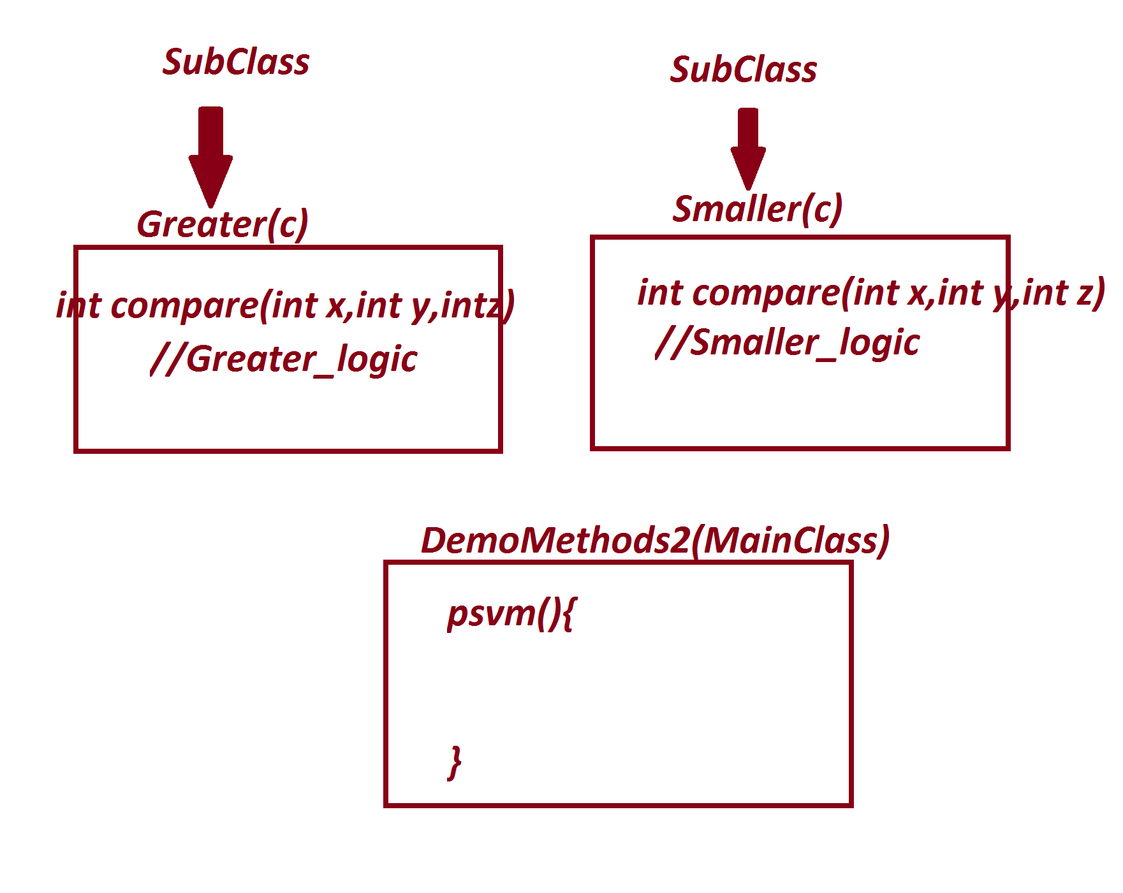

***import java.util.Scanner;***

***class Greater***

***{***

***int compare(int x,int y,int z)***

***//return type Instance method with parameter memory in object***

***{***

***if(x>y && x>z) return x;***

***else if(y>x && y>z) return y;***

***else return z;***

***}***

***}***

***class Smaller***

***{***

***int compare(int x,int y,int z)***

***//return type Instance method with parameter memory in object***

***{***

***if(x<y && x<z) return x;***

***else if(y<x && y<z) return y;***

***else return z;***

***}***

***}***

***class DemoMethods2***

***{***

***public static void main(String[] args)***

***{***

***Scanner s = new Scanner(System.in);***

***System.out.println("Enter the int value1:");***

***int v1 = s.nextInt();***

***System.out.println("Enter the int value2:");***

***int v2 = s.nextInt();***

***System.out.println("Enter the int value3:");***

***int v3 = s.nextInt();***

***System.out.println("=====Choice====");***

***System.out.println("1.Greater\n2.Smaller");***

***System.out.println("Enter the choice:");***

***int choice = s.nextInt();***

***switch(choice)***

***{***

***case 1:***

***Greater gt = new Greater();***

***int r1 = gt.compare(v1,v2,v3);***

***System.out.println("GreaterValue:"+r1);***

***break;***

***case 2:***

***Smaller sm = new Smaller();***

***int r2 = sm.compare(v1,v2,v3);***

***System.out.println("SmallerValue:"+r2);***

***break;***

***default:***

***System.out.println("Invalid Choice...");***

***}//end of switch***

***}***

***}***

***o/p:***

***Enter the int value1:***

***12***

***Enter the int value2:***

***13***

***Enter the int value3:***

***14***

***=====Choice====***

***1.Greater***

***2.Smaller***

***Enter the choice:***

***2***

***SmallerValue:12***

***===============================================***

***Assignment-1:***

***wap to read two integer values and perform the following***

***operations based on user choice:***

***1.add***

***2.sub***

***3.mul***

***4.div***

***5.modDiv***

***Diagram:***

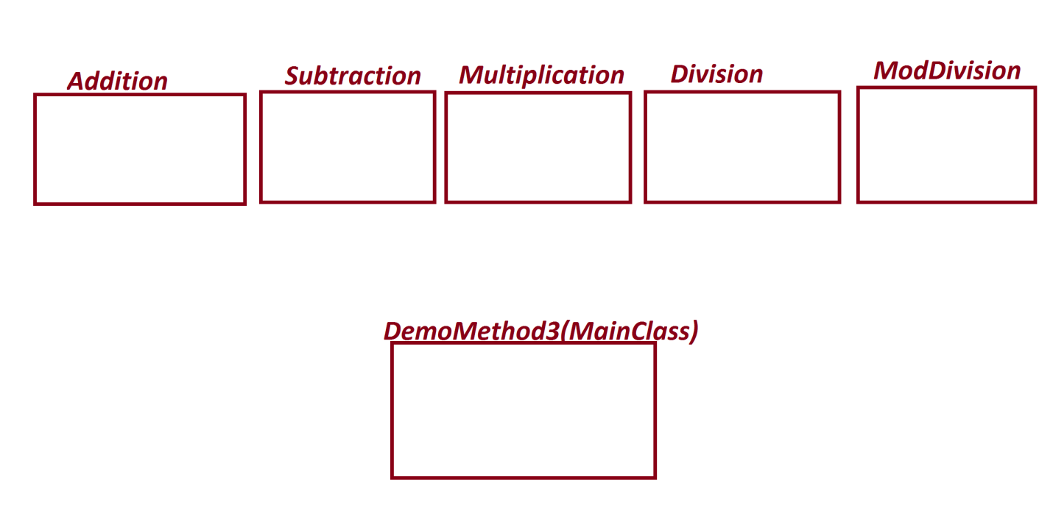

***===================================================***

***Assignment-2:***

***wap to read six submarks and calculate:***

***totMarks***

***percentage***

***result***

***Diagram:***

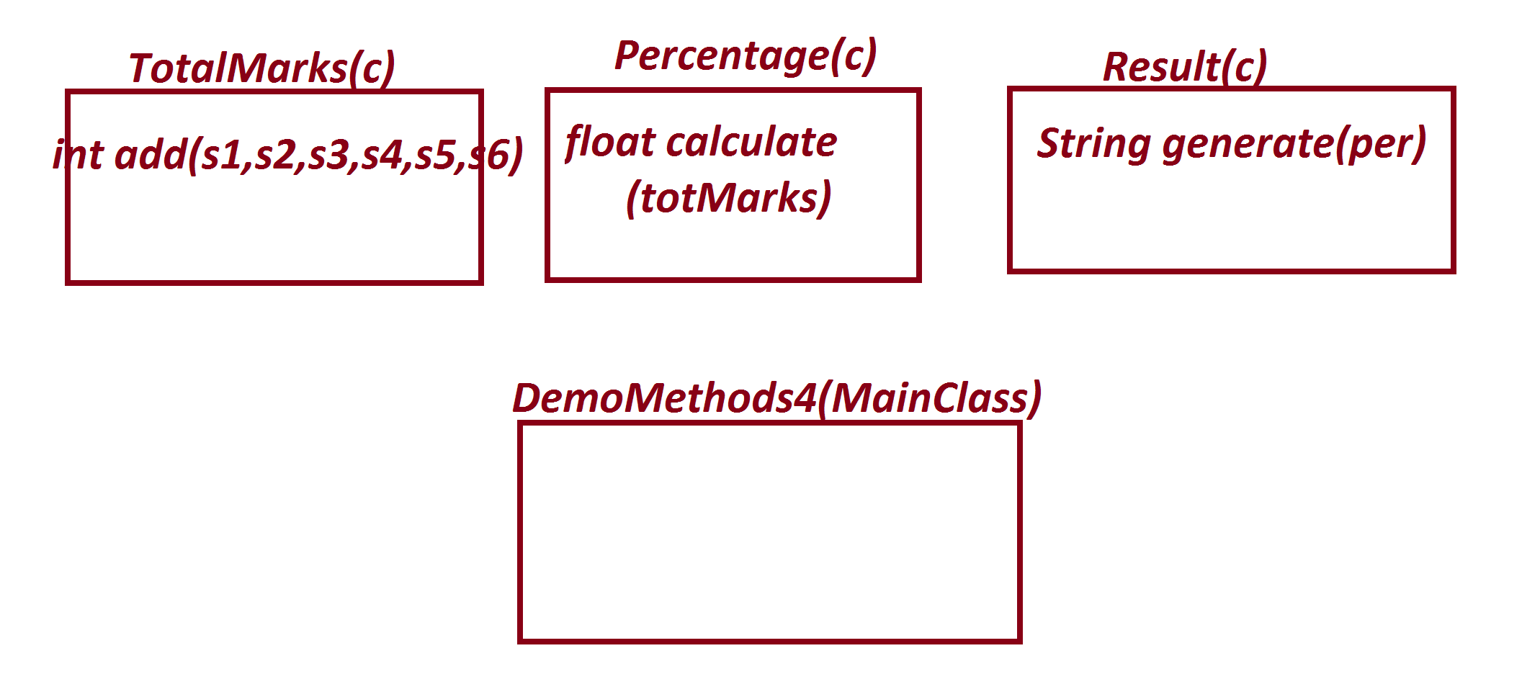

***Note:***

***(i)If all the Sub marks are in b/w 0 to 100 then perform***

***calculations,else msg as "Invalid marks".***

***(ii)result based on per as follows:***

***70 to 100 ===>Distinction***

***60 to <70 ===>FirstClass***

***50 to <60 ===>SecondClass***

***35 to <50 ===>ThirdClass***

***else ===>Fail***

***=======================================================***